KNOWLEDGE CENTRE

Nine blockchain opportunities that telecoms operators should explore

13 June 2016 | PDF (3 pages)Content type: Article

Research programme:

[DES](http://www.analysysmason.com/services/Research/Digital-economy/Digital-Economy-Strategies/)

http://www.analysysmason.com/contentassets/6b68ad46932d4b60bfd8f3513b176b27/enrique_velasco_castillo_50_by_50.jpg

[ENRIQUE VELASCO-CASTILLO](http://www.analysysmason.com/People/Enrique-Velasco-Castillo/)Senior Analyst, Research

**"Vendors should take the lead and explore novel blockchain solutions for telcos."**

Companies in a variety of sectors are already exploring the potential of blockchain (the technology behind cryptocurrencies, such as Bitcoin) to make common transactional processes cheaper, faster and more transparent.1 Telecoms will be no exception, and operators should consider how blockchain could impact their business and the opportunities it could present. Next-generation blockchains, which include smart contracts and lower computational requirements, are likely to have an impact on telecoms operational areas and digital services, including billing, eSIM provisioning, number portability databases and mobile money.2

**Figure 1:** Nine areas where telecoms operators could deploy blockchain technology

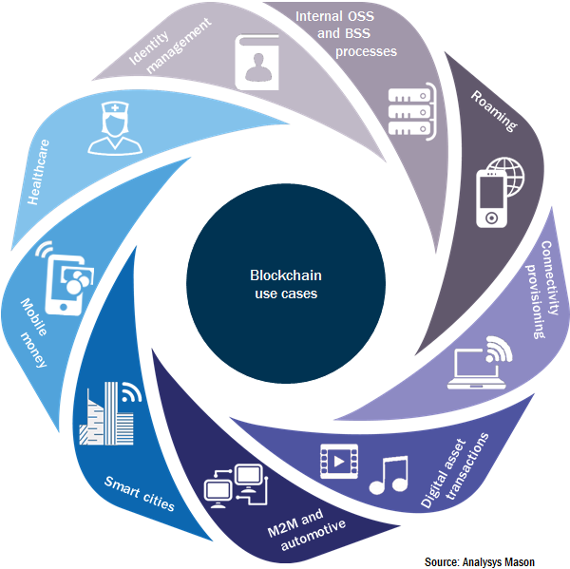

***Interest in novel blockchain applications is no longer restricted to finance***

Until recently, blockchains were exclusively associated with cryptocurrencies and were thus primarily of interest to financial institutions, regulators and enthusiasts. However, the new breed of ‘programmable’ blockchain platforms, such as Ethereum, has broadened the applicability of this technology beyond financial services and cryptocurrencies. Some of the new features introduced by second-generation blockchains include ‘smart contracts’ – agreements formalised in code – and private, or permissioned, blockchains.

Vendors, such as IBM and Microsoft, are already providing blockchain solutions to a number of industries. We may see the first telco-specific solutions in activities such as M2M, IoT, smart cities and automotive in late 2016. In fact, some operators are already exploring applications of blockchain technology, as described below.

* In August 2015, Verizon Ventures invested in Filament, a start-up developing connected modules to allow industrial assets to act as autonomous agents. These agents can then communicate via long-range, decentralised mesh networks and transact data using blockchains and smart contracts.
* Orange launched its ChainForce initiative in June 2015 with the intention of encouraging established companies and start-ups to explore new blockchain technologies and use cases. Orange Digital Ventures also invested in US-based start-up Chain, which is developing enterprise-grade blockchain solutions for the financial industry and other transactional services, in September 2015.
* In May 2016, du announced a pilot programme to facilitate the secure transmission of electronic health records (EHRs) in the UAE. It intends to do this through a blockchain-based solution in partnership with the Global Blockchain Council, which is itself a partnership between industry and government. Additionally, du has established partnerships with Dubai Tourism and Loyyal to provide blockchain-enabled loyalty solutions for tourism (Dubai Points).

Blockchains are suitable for any kind of digital data where shared write access for a number of parties is necessary. In these instances, trust (authentication) and consensus about data integrity are often important, but the existence of a trusted third-party provider may be either undesirable or too costly. Blockchain provides a solution to this problem.

Smart contracts on blockchains enable autonomous transactions between machines. For example, an electric car could ‘pay’ an autonomous charging station for power or on crossing a tollgate. These autonomous devices and networks may provide opportunities for operators willing to remain at the forefront of new technologies.

***Blockchain solutions can help telcos cut costs and make their digital services more competitive***

Several areas of operators’ activities could be improved through the implementation of blockchain-based solutions, which may be public, private or a hybrid of both. Some example use cases for telecoms operators include their own internal processes, as well as digital value-added services, as detailed below.

* **Internal processes:** OSS and BSS processes (such as billing, eSIM provisioning and number portability databases) can benefit from hybrid blockchains, which have both public and private (intra-firm) facets.
* **Roaming:** hybrid blockchains with permissioned and public components could facilitate the implementation of databases that usually require costly integrations and trusted access settings. One possible example is databases used for subscriber authentication during roaming.
* **Connectivity provisioning:** public Wi-Fi authentication and payments could be made more cost-effective through autonomous blockchain-based transactions between devices and access points.
* **Digital asset transactions:** the extremely low transaction costs enabled by blockchains (compared to those of credit or debit card transactions, for example) make them amenable to micropayment-based business models for digital assets, including music, mobile games, gift cards and loyalty points.
* **M2M and automotive:** it is likely that some of the first applications of blockchains to telecoms will be in M2M and automotive, as described in the examples above.
* **Smart cities:** public blockchains are particularly suited to use cases where high levels of transparency and auditability are required, such as smart city initiatives. Blockchain-enabled smart charging stations are being explored by German utility RWE, while South African start-up Bankymoon allows smart meter users to pay for electricity with Bitcoin.
* **Mobile money:** distributed ledgers and cryptocurrencies could enable more cost-effective international remittances between subscribers of an operator’s opcos in different countries. Blockchains could also reinvigorate direct carrier billing by significantly reducing the costs of micro-transactions.
* **Healthcare:**secureEHR storage and transmission on permissioned blockchains.
* **Identity management:** Microsoft is developing a blockchain-based identity management platform to enable authentication across devices, apps and organisations. Operators could develop similar solutions, or partner with organisations developing them.

Operators that are embarking on the process of transitioning to IP-based and virtualised networks should consider the potential of blockchain-based solutions. These could both facilitate the integration of their systems and make their internal, as well as client-facing, processes more cost-effective.

***Vendors should take the lead and explore blockchain solutions for telcos***

R3 is an industry consortium of over 40 banks, including BBVA, Credit Suisse and J.P. Morgan. Its aim is to research and develop blockchain technology for financial applications beyond cryptocurrencies and invest in promising early-stage initiatives. Through its work, the financial industry has identified use cases where blockchain solutions can provide value by making interoperability between internal systems easier, as well as by lowering infrastructure and regulatory compliance costs.

Similarly, telecoms applications of blockchain technology are ripe for innovation. Vendors could be instrumental in leading this transformation by developing solutions that make the most of their operator clients’ virtualised, IP-based next-generation networks. These networks can be coupled with the capabilities of blockchains to enable cost-effective, distributed, resilient and transparent transactional processes.

Analysys Mason is experienced in advising on all aspects of technology strategy. We can assist telecoms operators and vendors in identifying the most attractive opportunities presented by blockchain for both internal processes and digital services. For more information about our services, please contact Enrique Velasco-Castillo at [**enrique.velasco-castillo@analysysmason.com**](mailto:enrique.velasco-castillo@analysysmason.com).

*1 For an overview of blockchain technology, see Analysys Mason’s****[Permissionless innovation with blockchain technology: computer says yes](http://www.analysysmason.com/About-Us/News/Insight/permissionless-innovation-blockchain-Apr2016/)****.*

*2 A more detailed exposition on blockchain opportunities can be found in Analysys Mason’s*[***Blockchain technology: emerging opportunities for operators***](http://www.analysysmason.com/Research/Content/Short-reports/blockchain-opportunities-operators-Jun2016-RDMY0/)*.*